Press release ifm-pm 853/0226
Area: Company news

A successful year despite geopolitical challenges –
balance sheet figures for 2025 show strong growth at ifm
Essen, 13. April 2026 – The ifm group ended 2025 on a very positive note. Sales, adjusted for currency effects, increased by 10% to EUR 1.47 billion. “This very positive result for 2025 is particularly remarkable as we were able to achieve strong growth worldwide despite ongoing geopolitical challenges – almost exactly in line with our plans,” says Christoph von Rosenberg, CFO of the ifm Group. While demand in the German market declined, caused in particular by the weak order situation in the mechanical engineering sector, this was more than offset by strong growth in the Asia-Pacific region and the Americas. Strong momentum came especially from the process industry, where a number of new products met with a very positive customer response and drove substantial growth in this segment.
Despite significant exchange rate effects, earnings before interest and taxes (EBIT) increased slightly by 1% compared to the previous year to reach EUR 69 million. The workforce grew to around 9,120 employees. More than 5,260 of these are based in Germany. The company’s innovative strength is clearly evident in the approximately 1,500 employees working in research and development.
Following the change of name to ifm group se on 1 January 2025, the investor KKR has held a minority stake since October 2025. Through this partnership, the family-owned business aims to secure future success and sustainable growth for the next generation. One of the highlights of the past year was the start of construction on a new plant in Suzhou, China, in April. Production at this sustainable production site, which complies with the DGNB Gold standard, is scheduled to begin in the first quarter of 2027. This will enable ifm not only to maintain its 20-year long sales presence in this important market, but also to reinforce its position through local production and R&D expertise. With these milestones, ifm sees itself very well positioned for the future and expects positive growth again in the current year.

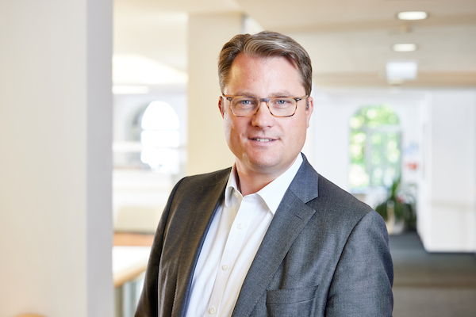 | ifm-pm 853 print.jpg  Christoph von Rosenberg is CFO of the ifm group of companies

About the ifm group of companies

From a passion, to an idea, to success. Since its foundation in 1969, ifm has developed, produced and sold sensors, controllers, software and systems for industrial automation and for SAP-based solutions for supply chain management and shop floor integration worldwide. As one of the pioneers of Industry 4.0, ifm develops and implements consistent solutions to digitalise the entire value chain “from sensor to ERP”. Today, the second-generation family-run ifm group has more than 9,120 employees, including more than 5,260 in Germany, and is one of the worldwide market leaders. The group combines the internationality and innovative strength of a growing group of companies with the flexibility and close customer contact of a medium-sized company.
Printing free of charge – reference copy requested.

Editorial enquiries  Agentur Dr. Lantzsch  Jörg Lantzsch  Müllerstr. 5  65183 Wiesbaden  www.drlantzsch.de  Tel.: +49 611 205 93 71  Email: info@drlantzsch.de | Contact  ifm electronic gmbh  Simone Felderhoff  Friedrichstr. 1  45128 Essen  www.ifm.com  Tel.: +49 201 24 22 0  Fax: +49 201 24 22 1200  Email: presse@ifm.com

